***echo***is a built-in [*command*](http://www.linfo.org/command.html) in the *bash* and *C* [*shells*](http://www.linfo.org/shell.html) that writes its [*arguments*](http://www.linfo.org/argument.html) to [*standard output*](http://www.linfo.org/standard_output.html).

***cat***is one of the most frequently used [commands](http://www.linfo.org/command.html) on [Unix-like](http://www.linfo.org/unix-like.html) [operating systems](http://www.linfo.org/operating_systems_list.html). It has three related functions with regard to text files: displaying them, combining copies of them and creating new ones.

**The *append operator*,** which is similar to the output redirection operator except that it is represented by two successive rightward pointing angle brackets (>>) and adds text from a file or other source to the end of file, if a file with the target name already exists, rather than overwriting the file.

**The *output redirection operator*** is a rightward pointing angular bracket (>) that is used in [*shells*](http://www.linfo.org/shell.html) to [*redirect*](http://www.linfo.org/redirection.html) [*standard output*](http://www.linfo.org/standard_output.html) to a [file](http://www.linfo.org/file.html), where it is written and saved, or to a device (such as a printer, where it is printed).

**The *input redirection operator***, which is represented by a leftward-pointing angular bracket (<), redirects [*standard input*](http://www.linfo.org/standard_input.html) from its default (which is text typed in at the keyboard) so that the data comes instead from a file. The*standard error redirection operator*, which consists of a rightward facing angular bracket preceded directly (i.e., without any intervening space) by the numeral 2 (2>), is used to redirect the [*standard error*](http://www.linfo.org/standard_error.html) (i.e., the destination of error messages from command line programs)

**The**[***pipe***](http://www.linfo.org/pipe.html), which is represented by the vertical bar [character](http://www.linfo.org/character.html) (|), can also be considered a type of output redirection operator. However, it differs from the rightward pointing angle bracket operator in that it only redirects standard output to another program and not to a file or device.

**An *inode*** is a [*data structure*](http://www.linfo.org/data_structure.html) on a *[filesystem](http://www.linfo.org/filesystem.html)* on [Linux](http://www.linfo.org/linuxdef.html) and other [Unix-like](http://www.linfo.org/unix-like.html) [operating systems](http://www.linfo.org/operating_system.html) that stores all the [information](http://www.linfo.org/information.html) about a [*file*](http://www.linfo.org/file.html) (such as size, permission, etc) except its name and its actual [data](http://www.linfo.org/data.html).

**Inode contain:**

* All meta-information (size, permission, etc)
* Reference count: how many hard links to the inode
* Pointer to actual file data
* A unique number that identified itself

**Hard links:** an entry in a file system “directory” that points to an inode

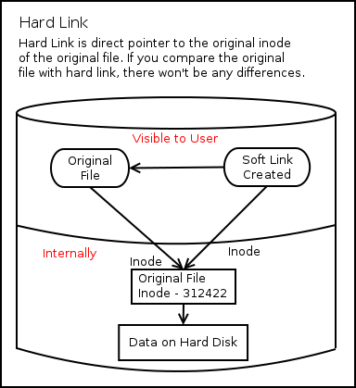

**Symbolic links:** or Symlinks are the easiest to understand, because for sure you have used them, at least when you were using Windows. Soft links are very similar to what we say “Shortcut” in windows, is a way to link to a file or directory. Symlinks doesn’t contain any information about the destination file or contents of the file, instead of that, it simply contains the pointer to the location of the destination file. In more technical words, in soft link, a new file is created with a new inode, which have the pointer to the inode location of the original file. This can be better explained with a diagram:

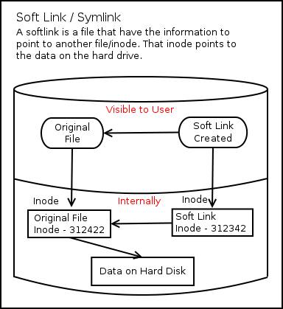

**Examples of using the umask command**

To give yourself full permissions for both files and directories and prevent the group and other users from having access:

**umask 077**

This subtracts 077 from the system defaults for files and directories 666 and 777. Giving a default access permissions for your files of 600 (rw-------) and for directories of 700 (rwx------).

To give all access permissions to the group and allow other users read and execute permission:

**umask 002**

This subtracts 002 from the sytem defaults to give a default access permission for your files of 664 (rw-rw-r--) and for your directories of 775 (rwxrwxr-x).

To give the group and other users all access except write access:

**umask 022**

This subtracts 022 from the system defaults to give a default access permission for your files of 644 (rw-r--r--) and for your directories of 755 (rwxr-xr-x).

Use this for every file

chmod oga+rwx fileName